

|  |  |
| --- | --- |
|  |  |
| **Subject Name:** | Fundamentals Of Image Processing |
| **Subject Code:** | BTPR2053 |

**Group Project**

**By**

|  |  |  |
| --- | --- | --- |
| **Student Name:** | Tan Meng  Wee |  |
| **Student ID:** | B170226B |  |
| **Class ID:** | BOSE17-B1 |  |

|  |  |  |
| --- | --- | --- |
| **Student Name:** | Teoh Suen Cheng |  |
| **Student ID:** | B170128B |  |
| **Class ID:** | BOSE17-B1 |  |

|  |  |
| --- | --- |
| **Lecturer Name:** | Dr. Pang Yee Yong |
| **Submit Date:** | 14th April 2020 |

1. **Introduction**

In our project, we are using the java coding language to produce our application. Our application name as “Tiffshop”. In this application, we using the gray color as a background and divide to two part which is the menu part and display part. For the display part, it is use for display the result after the user click the button at menu part. The menu part there are totally nine button which are Import, Information, Patterning, Dithering, Histogram, Convolution, Lass Pass Filtering, High Pass Filtering and Export. Each button contains their own function.

The Tiffshop can help the users to do some image processing like image convert. Also, the Tiffshop can be used by the customer who doing the job relate with the image processing.

1. **User Guide**

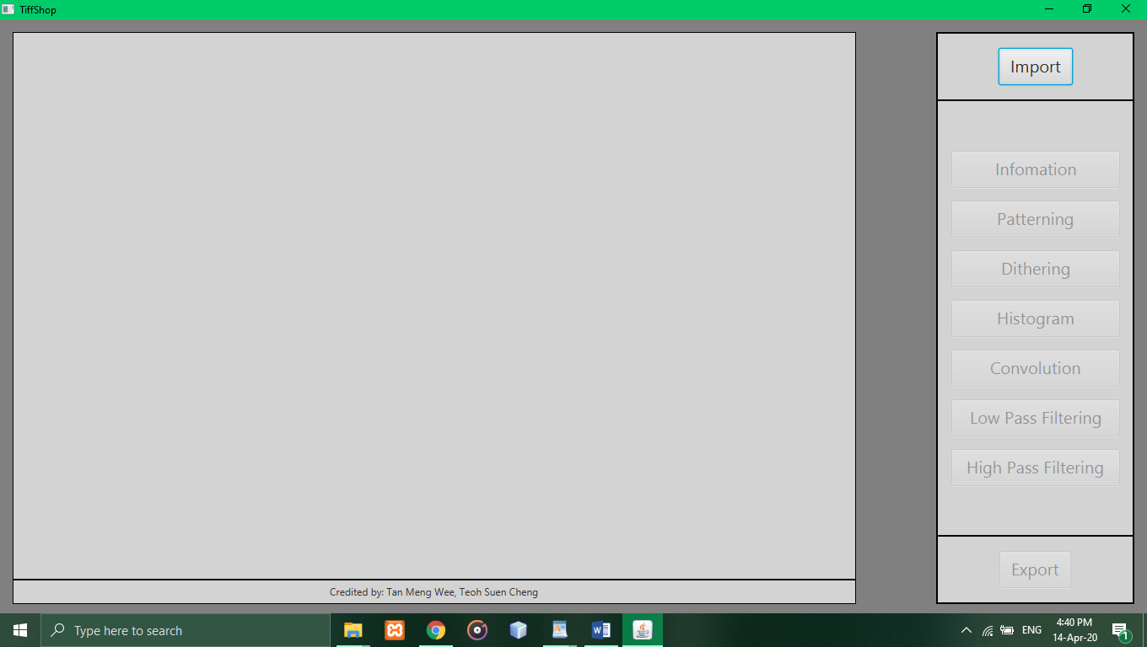

Figure 2.1

In figure 2.1, it is display the main page of our application. The left side is the display part and the right side is the menu part. For the first step, we need to click the “Import” button to import the tif file from our computer.

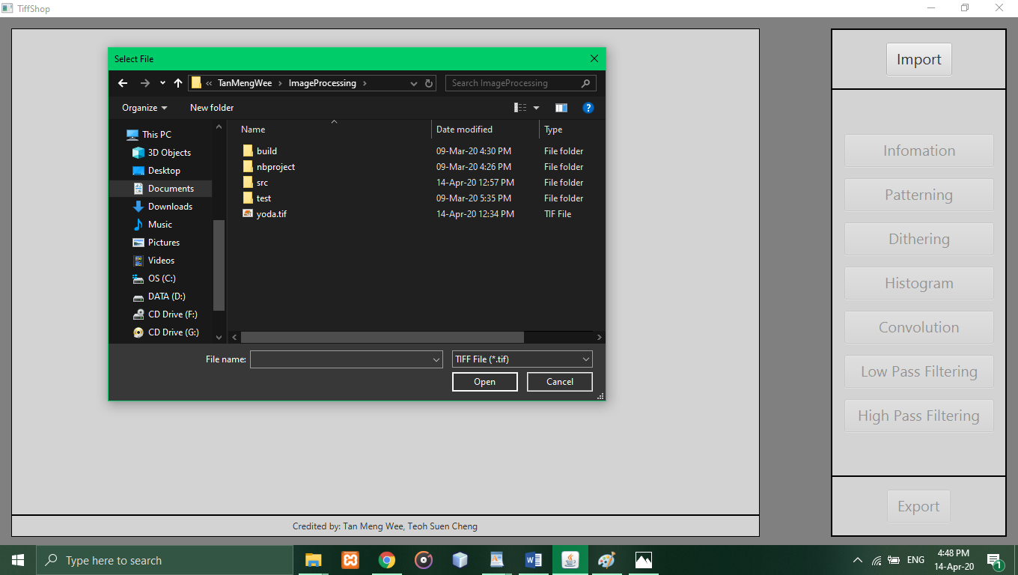

Figure 2.2

After we click the “Import” button the system will pop up the select file page. In this page, we need to choose the tif file which we wanted to process and click “open” to confirm and import the tif file.

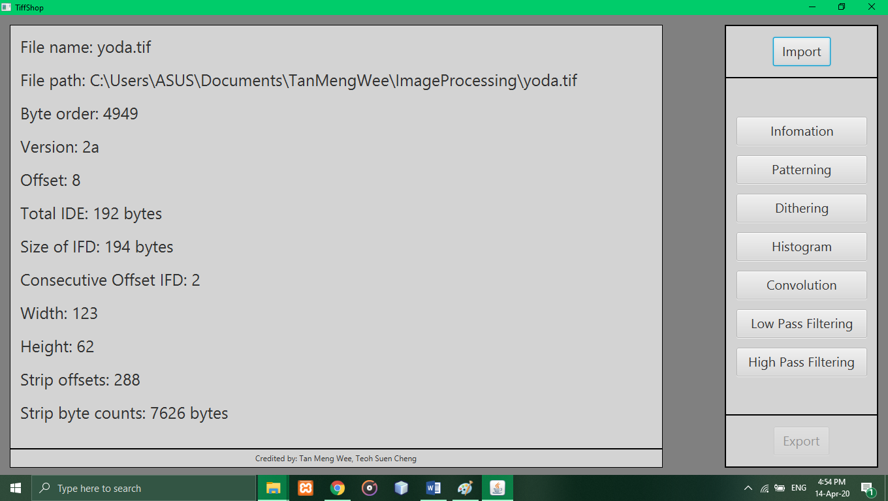

Figure 2.3

After we import the tif file, the system will display the information of tif file on display part. Now, we need to choose the type of image processing then we wanted there are six selections on menu part which are Patterning, Dithering, Histogram, Convolution, Lass Pass Filtering and High Pass Filtering. For example, we select the Convolution.

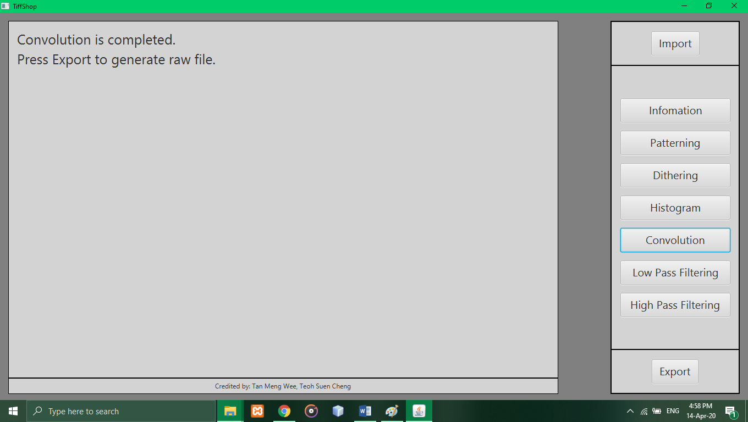

Figure 2.4

After we press the Convolution button, the system will display the information as show in Figure 2.4. For the last step, we just need to press the “Export” button to generate the raw file.

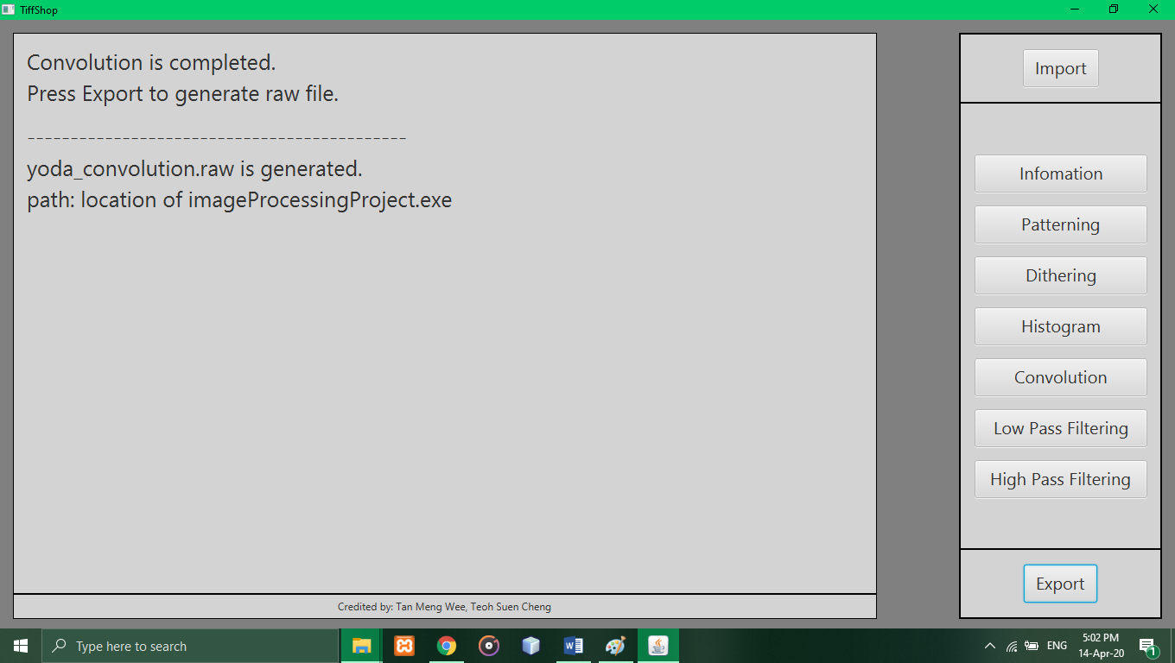

Figure 2.6

After we press the “Export” button, the new raw file will generated at the location which this application at.

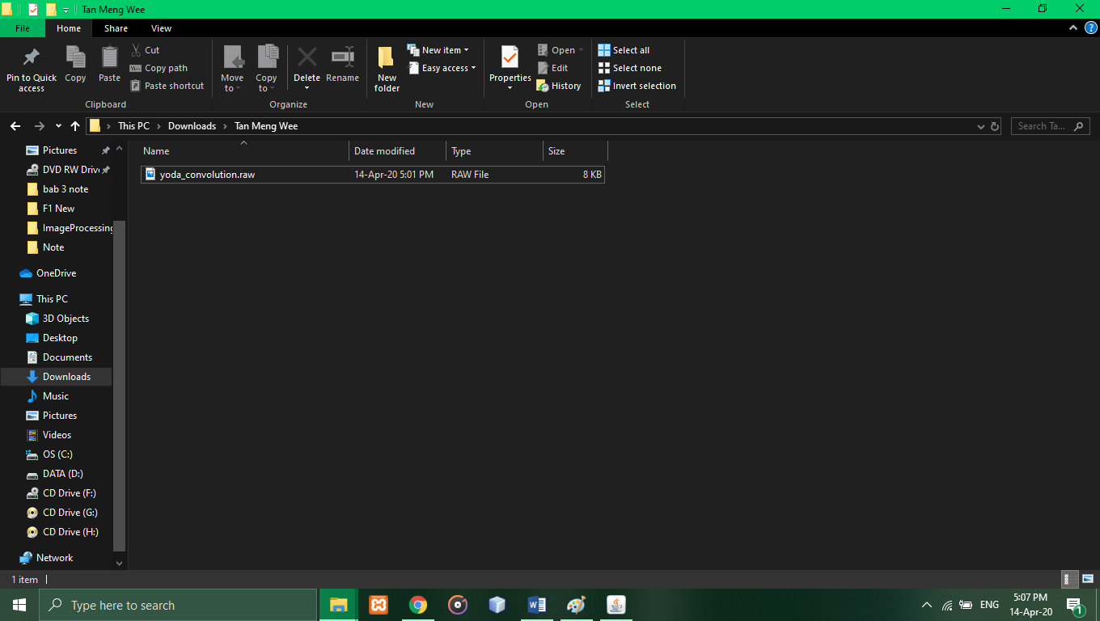

Figure 2.7

As we see in Figure 2.7, the new raw file was already generated.

**3.0 Conclusion**

As a conclusion, the Tiffshop can provide some convenience to the people who doing the work relate to image processing. Through this project, we learn a lot of theory that relate with the image processing and also our coding skill.

Even our project is not enough well as other famous application like photoshop, but we hope that we can improve this application by adding another new and convenience function in the future.